Federico Ariton

Exploratory data analysis

Index

Introduction 1

Dataset Overview 1

Dataset Structure 1

Data Source 1

Data Completeness 1

Top 10 Most Expensive Countries by Various Indices 2

1. Top 10 Most Expensive Countries by Cost of Living Index 2

2. Top 10 Most Expensive Countries by Rent Index 2

3. Top 10 Most Expensive Countries by Groceries Index 3

4. Top 10 Most Expensive Countries by Restaurant Price Index 4

5. Top 10 Most Expensive Countries by Local Purchasing Power Index 5

Box Plot Analysis 6

Local Purchasing Power by Country (Global Comparison) 8

Cost of Living and Rent Index Comparison (Bar Plot) 9

Global Cost of Living Index (Choropleth Map) 9

Weighted Total Index Calculation 10

Visualizing the Top 10 Countries by Total and Weighted Indices 11

Distribution Analysis Using Pie Charts 12

Correlation Analysis (Heatmap) 13

Comparative Analysis with New York City 14

EDA of Ireland 15

Distribution of Cost Indices in Ireland (Pie Chart) 15

Comparison of Ireland, New York City, and Global Averages (Histogram) 17

Conclusion 17

Cost of Living Index Analysis

# Introduction

This report provides an in-depth analysis of global cost of living data for various countries. The data includes indices such as the Cost of Living Index, Rent Index, Groceries Index, Restaurant Price Index, and Local Purchasing Power Index, with a baseline of 100 for New York City. The primary goal of the analysis is to understand the cost structure in different countries, compare key metrics, and generate insights about how various components like rent and food contribute to the overall cost of living,a special focus is placed on Ireland, with comparisons to New York City and global averages.

# Dataset Overview

Dataset Structure:

The dataset consists of 121 countries with the following indices:

Cost of Living Index: Measures the relative cost of consumer goods.

Rent Index: Reflects rental prices in each country.

Cost of Living Plus Rent Index: Combines both the cost of living and rent.

Groceries Index: Measures the cost of groceries.

Restaurant Price Index: Reflects the price of dining out.

Local Purchasing Power Index: Measures residents' purchasing power relative to living costs.

## Data Source

https://www.kaggle.com/datasets/myrios/cost-of-living-index-by-country-by-number-2024/data

Data Completeness:

No missing values were found, ensuring a complete analysis.

Data types are appropriate, with numerical values for indices and categorical data for country names.

# Top 10 Most Expensive Countries by Various Indices

## 1. Top 10 Most Expensive Countries by Cost of Living Index

A bar chart was created to show the Top 10 Most Expensive Countries based on the Cost of Living Index. This index reflects the overall cost of consumer goods and services relative to New York City.

Switzerland tops the chart, followed by Bahamas and Iceland. These countries are significantly more expensive than others, as indicated by their high cost of living indices.

Singapore and Barbados also make the top 5, highlighting the high living expenses in these countries.

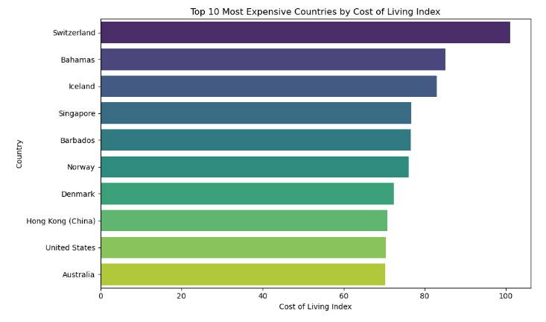

Figure 1 Bar chart 10 Most Expensive Countries by Cost of Living Index

## 2. Top 10 Most Expensive Countries by Rent Index

A separate bar chart was generated to display the Rent Index for the top 10 countries with the highest cost of living.

Singapore stands out with a Rent Index of 67.2, much higher than other countries in the top 10. This reflects Singapore’s high rental prices, contributing heavily to its overall cost of living.

Switzerland and Bahamas also have significant rent costs, with rent being a key factor in the high cost of living.

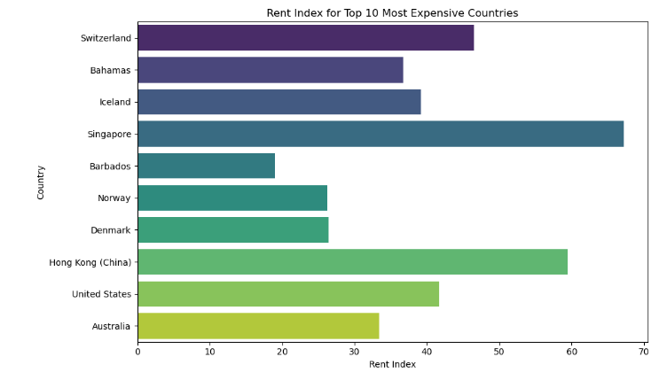

Figure 2 Bar chart Top 10 Most Expensive Countries by Rent Index

## 3. Top 10 Most Expensive Countries by Groceries Index

Another bar chart was plotted for the Groceries Index, showing how much groceries cost in the top 10 most expensive countries.

Switzerland and Iceland have the highest Groceries Index values, indicating that the cost of groceries is a significant contributor to the overall high cost of living in these countries.

Bahamas and Barbados also have notably high grocery prices.

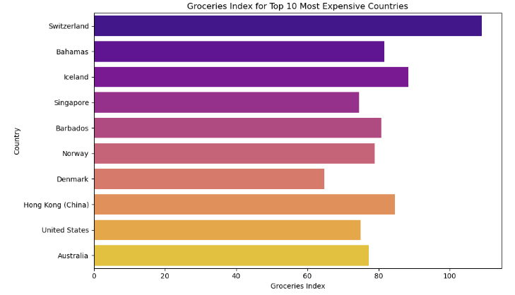

Figure 3 Bar chart Top 10 Most Expensive Countries by Groceries Index.

## 4. Top 10 Most Expensive Countries by Restaurant Price Index

The Restaurant Price Index was analyzed for the top 10 most expensive countries to reflect the cost of dining out.

Once again, Switzerland tops the chart, followed closely by Iceland and Bahamas, indicating that dining out is significantly more expensive in these countries compared to the rest of the world.

Singapore has a relatively lower Restaurant Price Index compared to other expensive countries, suggesting that dining out is more affordable relative to the overall cost of living.

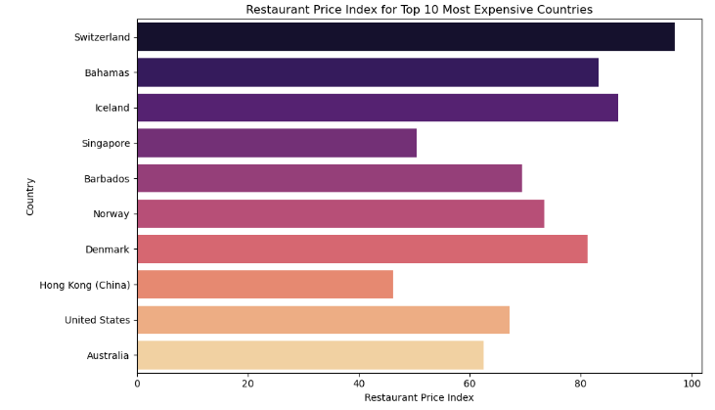

Figure 4 Bar chart Top 10 Most Expensive Countries by Restaurant Price Index

## 5. Top 10 Most Expensive Countries by Local Purchasing Power Index

The Local Purchasing Power Index measures how much purchasing power residents of a country have relative to the cost of living.

Switzerland has the highest Local Purchasing Power Index, indicating that despite high costs, residents in Switzerland have relatively high incomes and can afford the cost of living.

Singapore and Iceland also rank high in terms of purchasing power, making life relatively affordable despite high prices for goods and services.

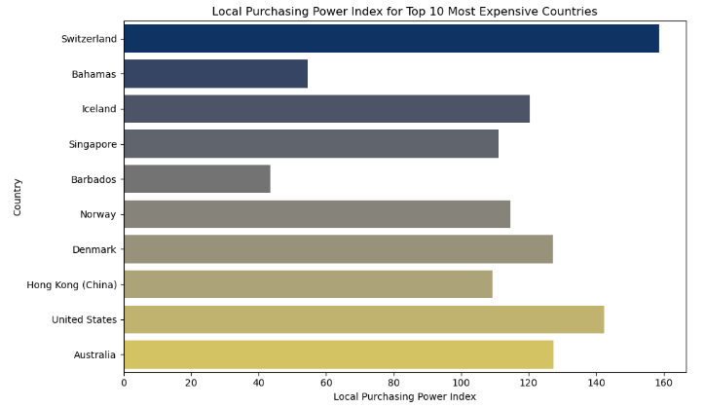

Figure 5 Bar chart Top 10 Most Expensive Countries by Local Purchasing Power Index

# Box Plot Analysis

A combined box plot was generated to compare the distributions of the various indices across all countries, The Cost of Living Index, Rent Index, Groceries Index, and Restaurant Price Index show significant variability across the top 10 countries.

The Local Purchasing Power Index has a more narrow distribution, suggesting that most top 10 countries have relatively strong purchasing power compared to the rest of the world also Switzerland has high costs across all indices but also enjoys the highest local purchasing power, making it more manageable for its residents.

Singapore's high cost of living is driven primarily by rent, while food costs are relatively moderate.

Bahamas and Barbados have high costs but lower purchasing power, suggesting that their residents face more financial challenges in managing everyday expenses.

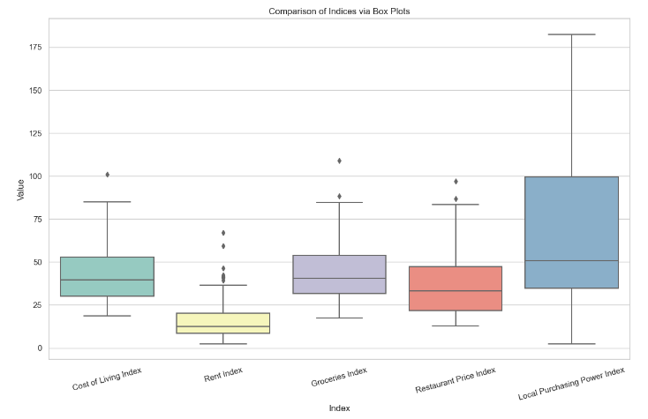

Figure 6 Box plot Comparison of indices via Box plot

# Local Purchasing Power by Country (Global Comparison)

A bar chart was created to show the Local Purchasing Power Index for all countries ranked in the dataset.

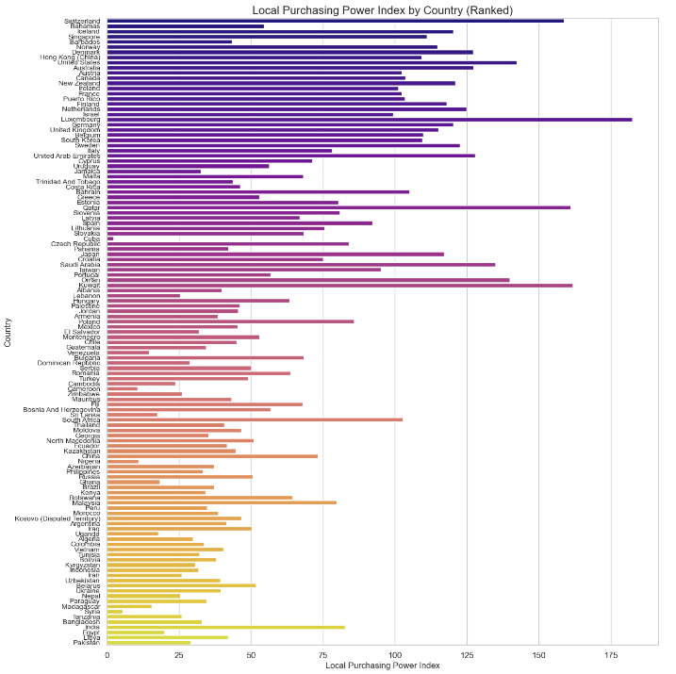

Figure 7 Bar chart Local Purchasing Power by Country

# Cost of Living and Rent Index Comparison (Bar Plot)

Using Plotly, a bar plot was generated to compare the Cost of Living Index and the Rent Index across all countries.

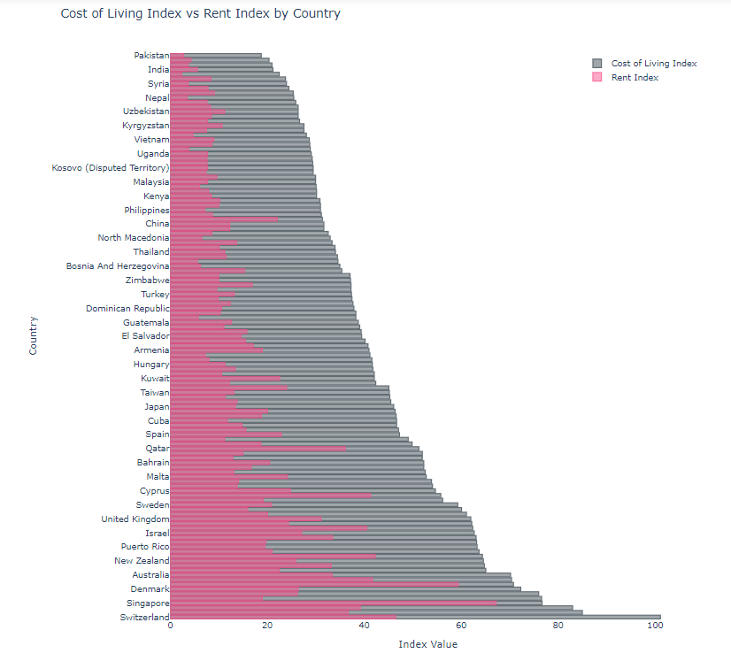

Figure 8 Bar plot Cost of Living and Rent Index Comparison

# Global Cost of Living Index (Choropleth Map)

A choropleth map was created to visually represent the Cost of Living Index on a global scale.

The Plasma color scale effectively highlights the stark contrasts between countries.

Countries in Western Europe, North America, and parts of Asia show the highest cost of living.

Developing nations in South Asia, Africa, and South America have significantly lower costs of living, as reflected by the cooler color gradients on the map.

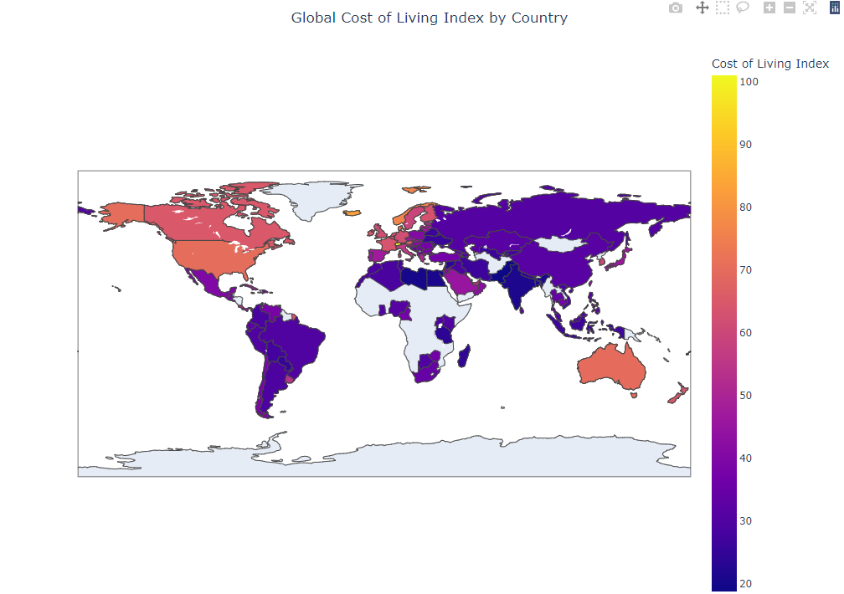

Figure 9 Map of Global cost of living Index by Country

# Weighted Total Index Calculation

In order to better account for the various factors that influence the cost of living in each country, a Weighted Total Index was calculated by assigning custom weights to the individual indices. This approach ensures a more holistic view of a country’s affordability by not only focusing on the Cost of Living Index but also considering the relative impact of rent, groceries, dining out, and local purchasing power.

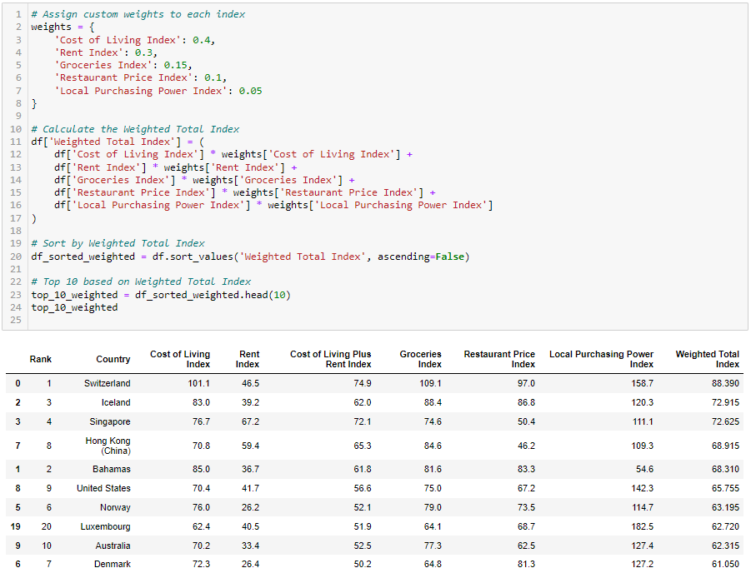

Figure 10 Coding and Representing the Weighted Total Index

## Visualizing the Top 10 Countries by Total and Weighted Indices

To better understand the rankings, bar charts were plotted comparing the Total Index (which is simply the sum of all the indices) and the Weighted Total Index (which applies the custom weights).

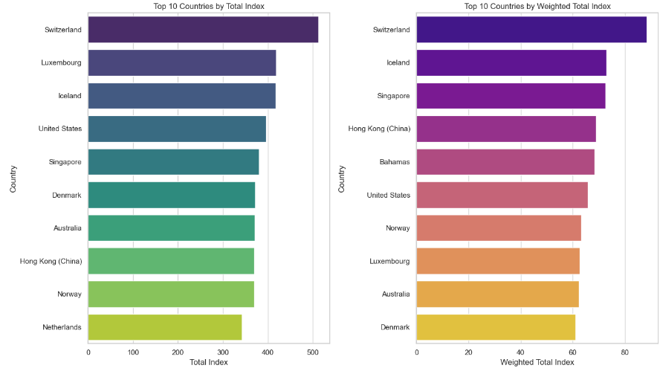

Figure 11 Comparison of the Total Index and Weighted Index

This comparison shows the importance of considering more than just the raw cost of living when assessing the affordability of a country. The Weighted Total Index reflects a country’s broader economic context, balancing cost with income levels and purchasing power.

## Distribution Analysis Using Pie Charts

Pie charts were generated to analyze the distribution of both the Total Index and the Weighted Total Index for the top 10 most and least expensive countries. This provides a clear visual representation of how much of the global cost burden each country carries.

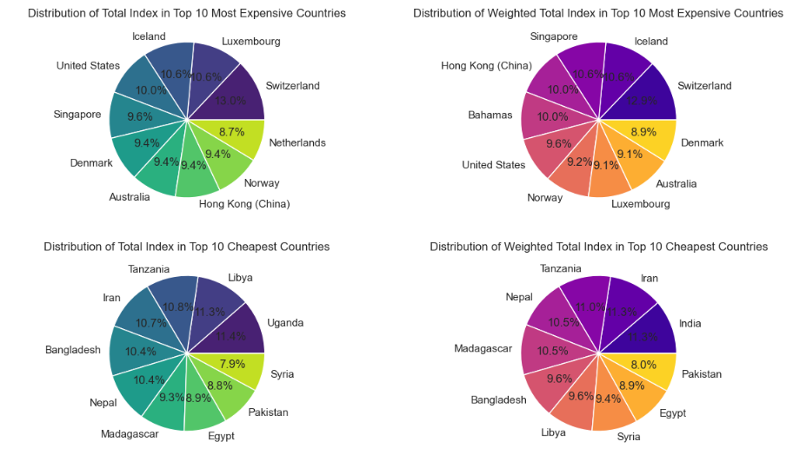

Figure 12 Pie Chart of the Distribution of Total Index and Weighted Index

The Weighted Total Index and its visual representations through pie charts provide a more accurate picture of affordability across the globe. While countries like Switzerland and Iceland are consistently expensive, the level to which their costs impact residents is partially offset by their strong purchasing power.

The comparison of the Total Index and the Weighted Total Index allows us to see which countries truly face high costs that are unaffordable (e.g., Bahamas), and which countries, though expensive, provide their residents with the means to comfortably afford those costs (e.g., Switzerland).

This section highlights the importance of considering both costs and income levels when assessing the overall affordability of living in a particular country. By applying weights to each index, we can better understand the relative impact of different cost components and how they affect the daily lives of residents around the world.

# Correlation Analysis (Heatmap)

A correlation matrix was computed and visualized using a heatmap to explore relationships between different indices, The Cost of Living Index has a strong positive correlation with the Groceries Index and Restaurant Price Index, meaning that food-related expenses are significant drivers of overall living costs.

The Rent Index also correlates highly with the Cost of Living Index, showing how housing can heavily influence the overall cost structure of a country.

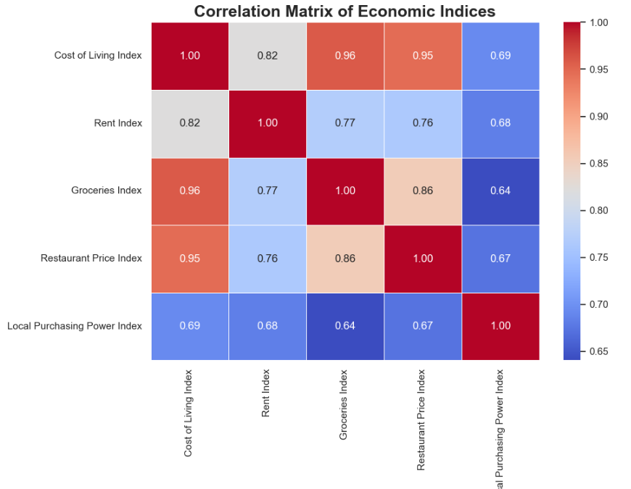

Figure 13 Correlation Matrix

# Comparative Analysis with New York City

Using the Cost of Living Difference from NYC as a baseline, bar plots were generated for the top 10 most expensive and cheapest countries.

Switzerland, Singapore, and Iceland rank much higher than New York City in terms of living costs.

Countries like Pakistan and Bangladesh have substantially lower costs across all indices when compared to New York City, highlighting global inequalities in living expenses.

Singapore's Rent Index is significantly higher than New York City's, further illustrating its challenging housing market.

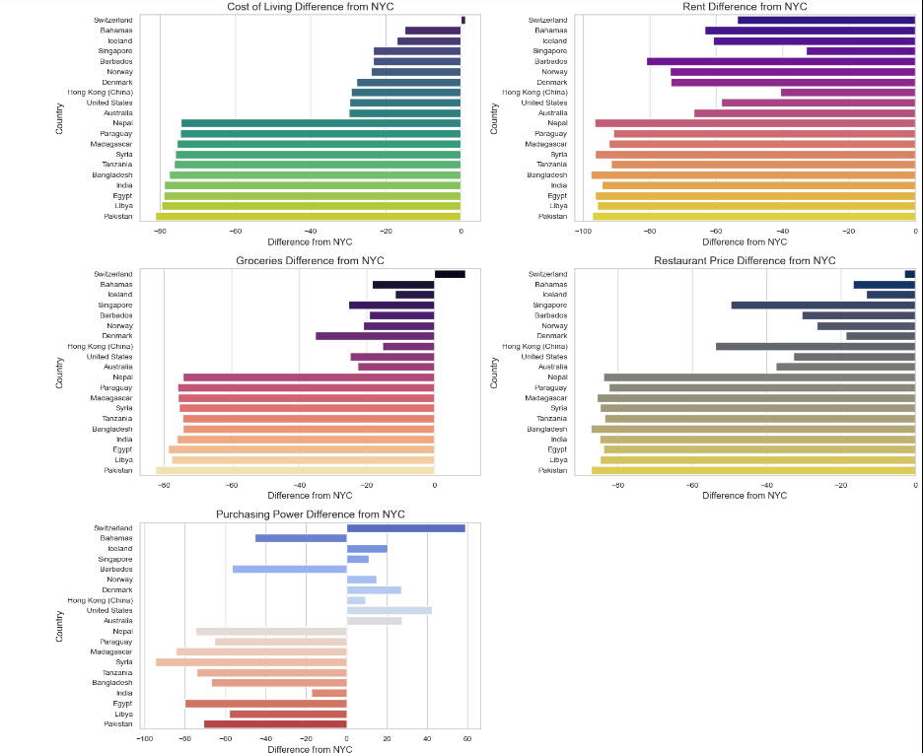

Figure 14 Bar Charts of the comparative from NYC to different countries

# EDA of Ireland

## Distribution of Cost Indices in Ireland (Pie Chart)

A pie chart was generated to visualize the distribution of cost indices in Ireland.

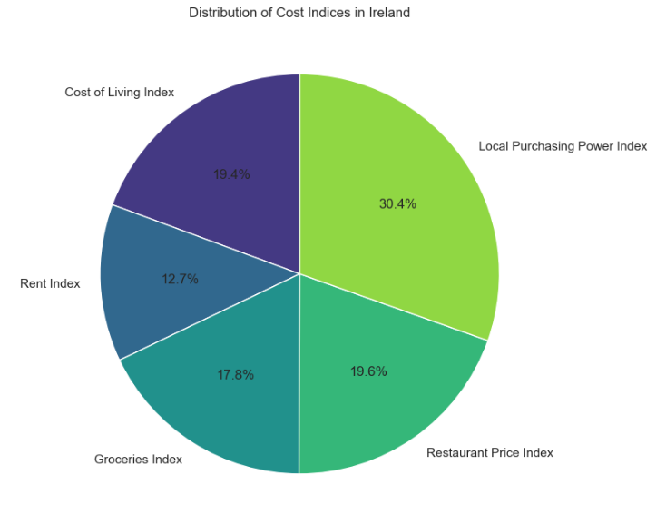

Figure 15 Pie chart of the Distribution of Cost Indices in Ireland

A bar chart was created to represent the individual values of Ireland's indices.

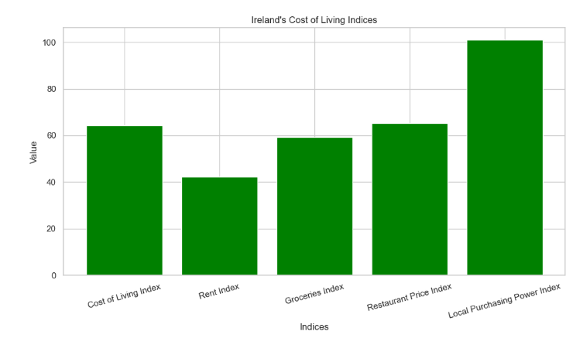

Figure 16 Bar chart of the cost Living in Ireland

## Comparison of Ireland, New York City, and Global Averages (Histogram)

A histogram was created to compare the key indices between Ireland, New York City (as a baseline), and the global averages.

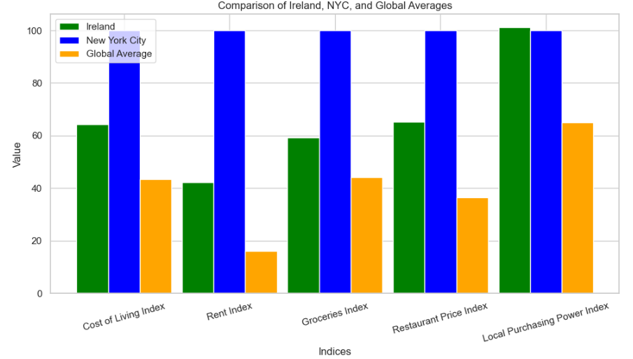

Figure 17 Bar chart Comparison of Ireland, New York City, and Global Averages

Ireland’s cost structure is heavily driven by rent and general consumer prices, but when compared to global standards, it remains moderately expensive. Despite lower rents and living costs relative to New York City, Ireland’s high living expenses can pose challenges to local residents, especially when considering their purchasing power.

Comparing Ireland to global averages and New York City, Ireland sits in a mid-tier position, where it is more affordable than major global cities but more expensive than many other countries. While groceries and restaurant prices are moderate, rent and overall cost of living remain high, putting some pressure on Irish residents' ability to save or spend freely.

# Conclusion

This analysis revealed several key insights into the global cost of living, with particular attention to Ireland:

Switzerland, Bahamas, and Iceland consistently rank as the most expensive countries based on a variety of indices, particularly driven by food and housing costs.

Ireland sits in a moderate position: more expensive than the global average but more affordable than New York City.

The Weighted Total Index provides a more holistic view by factoring in purchasing power, revealing that some countries with high living costs also have high incomes, allowing residents to maintain their standard of living.

Correlation analysis highlighted how rent and food are key drivers of global living costs, making them critical areas for future policy and investment